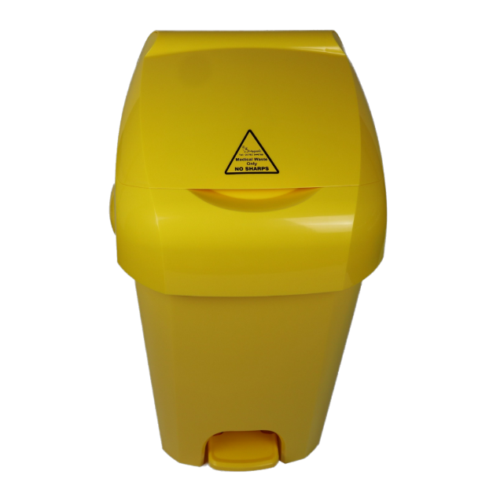

What goes in this bin?
✔ Non-infectious wound dressings
✔ Used PPE (gloves, aprons, masks) with no infection risk
✔ Vomit bowls or containers with no infection risk
✔ Incontinence products and nappies
✔ Sanitary products
✘ Needles and syringes
✘ Scalpels
✘ Broken glass from vials

